


Holyhead Primary Academy
SEN Information Report
Published July 2024

SENCo: Mrs Ruth McMenamin
Contact Details: 0121 556 0114
Academy Principal: Mrs Natalie Shipley
Trust Director of SEND: Mrs Sally Philpotts
SEND Link Governor:
SEN Policy
Contents
Purpose of the SEN Information Report 2
Holyhead Primary Academy Information 2
Identifying Children with Special Educational Needs 2
Consulting with Families and Young People 3
Arrangements for Assessing and Reviewing Progress 3
Whole School 4
SEN 4
Transition and Preparing for Adulthood 4
Joining Holyhead Primary Academy 4
Movement Between Phases of Education 5
Preparing for Adulthood agenda 5
Teaching Children with Special Educational Needs 5
Our Curriculum 5
Adaptations to our curriculum 5
Adaptations to the learning environment 6
Staffing 6
Department structure 7
Additional Staffing 7
Training 7
Engagement in Activities 7
Emotional and Social Development 8
Engaging with External Agencies 9
Sandwell Local Authority – Inclusive Learning Services 9
NHS Services 9
Social Care 9
Evaluating the Effectiveness of Provision 9
Governance 9
The Role of the Trust 9
The Role of the Principal 9
The Role of the SENCo 10
Local Offer Contribution 10
Complaints 10
Appendix 1 – SEN Data for 2023-2024 10
Appendix 2 – Interventions 2023-2024 11
Appendix 3 – SEND Training Record 2023-2024 12

Purpose of the SEN Information Report
All schools are required as part of the Children and Families Act (2014) to publish a Special Educational Needs Information Report.
The purpose of which is to provide information to our current and prospective families, the Local Authority and Government agencies. The SEN Information report provides details regarding the implementation of the Shireland Collegiate Academy Trust’s SEND Policy.
This report will be updated at least annually and include the required information as set out in the SEND Code of Practice 0 ‐25 Years (2015) Section 6.

Holyhead Primary Academy Information
Holyhead Primary Academy is currently one of 12 schools within the Shireland Collegiate Academy Trust, an inclusive trust that highly values a holistic approach to supporting all students, including those with SEND.
Holyhead Primary Academy is a good school following its most recent Ofsted Inspection in January 2022.

Holyhead Primary Academy is a one form entry primary school with 256 children on roll.

There are 50 children on the SEN register which is 19% of the school population. The highest area of needs are communication and language and cognition and learning.

A full breakdown of Holyhead’s SEN register can be found in Appendix 1.

Identifying Children with Special Educational Needs

High quality first teaching and additional interventions are defined through our annual dialogue across the school contributing to our provision management approach. These documents help us to regularly review and record what we offer EVERY child or young person in our care and what we offer additionally. These discussions also serve to embed our high expectations among staff about quality first teaching and the application of a differentiated and personalised approach to teaching and learning. We make it a point to discuss aspirations with ALL our learners.

Underpinning ALL our provision in school is the graduated approach cycle of:

All teachers are responsible for every child in their care, including those with special educational needs.

Assess: Class teachers assess the children’s learning on a daily basis identifying next steps in learning, an online tracking program is used to identify the objectives child can or cannot demonstrate independently. The Wakefield progression steps are used to assess children with SEND.
Plan: Class teachers plan lessons that are suitable for the needs of all children, The Wakefield progression steps are used to identify steps within learning. When necessary interventions are planned and carried out by class teachers and support staff with the guidance of the SENDCo.
Do: quality first teach is demonstrated on a daily basis to enable all children to make progress. Learning surgeries are used on a daily basis to ensure no children fall behind in their learning. The curriculum is personalised and interventions are carried out when necessary.
Review: Pupil progress meetings are carried out on a termly basis and the progress of all children is discussed. Interventions are monitored and evaluated. Having consulted with children, young people and their parents, all our additional provision (internal or external) is based on an agreed outcomes approach.

Where the school needs additional support or expertise to meet the needs of pupils with SEN, it may be necessary to gain the support of external agencies. The external agencies include, Educational Psychologist, Speech and Language Therapists, Occupational Therapists, Physiotherapists, Adivosry teacher for SEMH, Advisory teacher for Learning and CAMHS.

Consulting with Families and Young People
Involving parents and learners in the dialogue is central to our approach and we do this through:
Action/Event | Who’s involved | Frequency
Termly provision map targets | Class teachers, SENDCo, Parents and children | Termly
Parents’ evening | Class teachers and parents | Termly
Annual reports | Class teachers and parents | Yearly
Coffee mornings | SENDCo and parents | Termly

We will share with parents and carers where the school feels a pupil needs to be added to the SEND register. This means ongoing assessment demonstrates they need support ‘additional to’ or ‘different from’ the Univeral offer.
In the same way, when a child is accessing the curriculum successfully with quality first teaching and no further specialist support is needed, we will remove the child from the SEND register, and this will be shared with parents and carers.

Arrangements for Assessing and Reviewing Progress

Whole School

Informal assessments are carried out throughout the course of every lesson so that staff can immediately identify gaps in children’s learning and address any misunderstandings or support needs.
In Nursery and Reception, children are assessed in the first few weeks of the Autumn term or their first term of admission, through transition meetings with parents and sensitive classroom observation play-based learning activities.
In Years 1-6, the previous class teacher’s assessment levels for each pupil’s learning are passed onto the new class teacher to provide a ‘baseline’ by which to track progress for every child. We also use standardised assessment tests to support class teacher assessments.
Assessments are then carried out at the end of each term to track progress, monitor and difficulties and ensure that we don’t miss anything.
Every term a meeting is held between the senior leadership team (including the SENCO) and class teacher to discuss the progress of all the pupils in each class.
For any child who has not made expected progress or is working below expectations that are developmentally appropriate for them, support measures are agreed and put into place for that child. Assessment for all children is tracked and analysed to determine their progress.

SEN

The progress of children with SEND needs is assessed using a variety of methods, these include; tracking achieved Sandwell skills ladders or Wakefield progression step targets, baseline and exit data from completed interventions and progress report provided by Inclusion Support and/or speech and language.
Individual learning plans are reviewed on a termly basis with class teacher and parents ensuring next steps and targets are set.

Transition and Preparing for Adulthood

Joining Holyhead Primary Academy

When new children join Holyhead Primary Academy the children and their families are invited in for a tour of the school and complete paperwork with a member of staff, to ensure all information is provided for a successful start to school.
In addition to this, stay and play session are planned for all new children to provide the children with an opportunity to access their new environment. Home visits are conducted for Nursery and Reception children.
For children with SEND needs additional sessions are planned and parents are asked to attend. Professionals who are involved with the child are invited into school to meet with staff and parents to ensure all strategies and provision is put in place ready for a smooth transition.
Where necessary existing day care or schools are visited by the SENDCo to see the children in their current environment. Visits and play and stay sessions are arranged and key photographs are provided to the family to ensure the child can be fully prepared for their ne start at Holyhead.

Movement Between Phases of Education

Prior to the start of the academic year all children have the opportunity to meet their new class teacher for two afternoons within their new classroom. Children with SEND needs are given more time to meet their class teacher with the support of their existing support or class teacher.
All staff prepare for and are part of transition meetings where key information is share between existing and new class teachers and staff. This ensure staff are fully prepared for the needs of their new children.
For transition to high school, the SENDCo, and class teacher plan transition activities carefully. For our most vulnerable children, our SENDCo and Year 6 teacher work closely together to liaise with appropriate staff at the Secondary school, organising additional visits, days and tours for children to take part in summer schools if appropriate.

Preparing for Adulthood agenda

At Holyhead Primary Academy we ensure we help all children prepare for adulthood, for children with SEND needs this is carefully planned and shared with parents to ensure children’s life skills, health, community inclusion and independence skills are developed.

Teaching Children with Special Educational Needs

Our Curriculum

Our curriculum provides children with high quality first teaching which is supported by additional interventions to ensuring children have a broad and balanced curriculum.
Our curriculum provides a dynamic platform for our pupils to excel at Holyhead Primary Academy and beyond.
Our curriculum is cross-curricular, with literacy at its heart, driven through inspiring themes and underpinned by the development of key skills across the foundation subjects (History, Geography, Art and Design, Design Technology and Science.) There is a focus on Science, ensuring children’s scientific knowledge and investigation skills are well developed and ready for Secondary School. Our themes also encourage a love of the Arts and ensure we help children cultivate their own Cultural Capital for the world beyond school.

Adaptations to our curriculum

We will make the following adaptations to the curriculum to ensure all pupils’ needs are met:
- Differentiating our teaching and the curriculum to ensure the pupils are able to access it through, scaffolding, adult support, pre teaching, vocabulary support and preferred learning styles.
- Exploring the use of technology such as using electronic readers and I Pads to support independence
- Following the guidance of Inclusion Support to provide any recommended aids. Children with SEN or disabilities may, from time to time, require access to different equipment or facilities. We will aim to support these needs following an evidence based approach utilising internal and external resources.
- Individualised curriculums for those children who require it
Considerable thought, planning and preparation goes into utilising our support staff to ensure children achieve the best outcomes, gain independence and are prepared for adulthood from the earliest possible age.
- Support staff have been deployed on a needs basis supporting children with specific needs and delivered interventions when necessary.

Adaptations to the learning environment

All classroom are adapted to support children with SEND needs these included, visual timetables, now and next boards, individual work stations where necessary and communication friendly environments that are language rich.
A list of provisions for Holyhead Primary Academy can be found in Appendix 2.

Staffing

Department structure
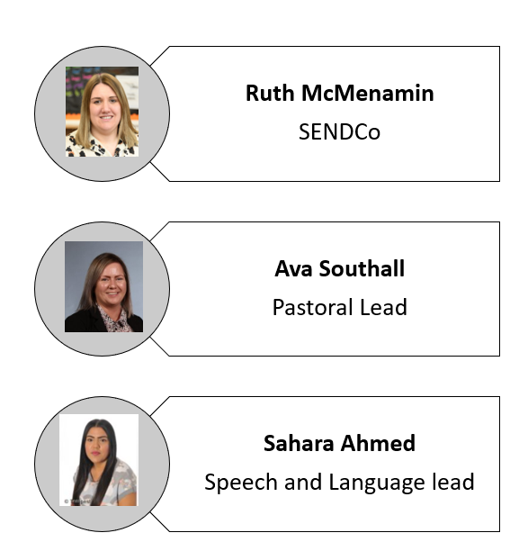

Additional Staffing
Enhanced Speech and Language therapists- NHS, HM
Base 25- 1:1 mentoring sessions

Training
Ongoing professional development is a priority within the Shireland Collegiate Academy Trust.
Training and CPD this year has focused on quality first teaching, ensuring the curriculum and classroom environment is adapted to support the needs of children with SEND. All support staff have received Circle of Friends training and training to manage children with Autism within the primary classroom. Specific training has been provided for staff who support children with complex needs such as Intensive Interaction and Objects of Reference.
Further support will be provided next year to support staff who deliver speech and language interventions and supporting children with sensory needs.
Please see Appendix 3 for the SEND training record for the 2023-2024 Academic year.

Engagement in Activities

Children with SEND are encouraged to engage in a variety of extra-curricular activities. After school clubs are planned and designed to cater towards the needs and interest of children with SEND need.
After school clubs attended by children with SEND:
Multi sports
Fizz, Pop Science
Gardening club
HEN drama
Football
Art club
Film club
Hockey
Cross stitch

Emotional and Social Development

All staff at Holyhead Primary Academy work with parents, pupils and professionals to address any barriers which may serve to disadvantage the learning experience of a child. We identify that all pupils need to be emotionally ready to engage in learning, this means positive mental health and wellbeing.
We provide wellbeing support for our pupils through mentoring and nurture programmes. Support is also provided and available through our passport to success programme which is led by staff within our Multi Academy Trust.
Staff within our academy have received Mental Health Training and there is a Senior Mental Health Lead who has undertaken DfE approved training programme.
Pupils are made aware of the importance to share things which may worry or concern them to Trusted Adults. Mental Health and wellbeing is addressed within the curriculum through Personal Development, where pupils are provided with strategies to deploy as and where required. Pupils are encouraged to do daily wellbeing checks where they can share how they are feeling, and appropriate actions can be taken.
Staff have engaged in and demonstrate a working knowledge of mental health and safeguarding following an appropriate training programme.
If children are having difficulties with their social and emotional development interventions are carefully planned and delivered to support the children.

Engaging with External Agencies

In order to secure further specialist expertise, Holyhead Primary Academy will often consult and liaise with the following external agencies:

Sandwell Local Authority – Inclusive Learning Services
- Educational and Child Psychologist
- Specialist Advisory Teacher for Learning
- Specialist Advisory Teacher for SEMH
- Complex Communication and Autism Team (CCAT)
- Sensory Support Team (HI/VI Teachers)
- Virtual School – LACE Development Workers

NHS Services
- Occupational Therapy
- Physiotherapy
- Speech and Language Therapy
- Hospital Consultants/Paediatricians
- Child and Adolescent Mental Health Service (CAMHS)
- School Health Nurses

Social Care
- Social Workers
- Early Help
- MST
A minority of Holyhead Primary Academies students with special educational needs live within neighbouring boroughs. If they require additional assessment or support, this is coordinated with the relevant Local Authority services.
Where a child or young person is looked after by the local authority and have a Special Educational Need, the SENCo will provide a high level of input into Personal Education Plan (PEP) meetings and may be a point of contact for alongside the Designated Teacher for Looked After Children with regards to special educational provision.

Evaluating the Effectiveness of Provision

Governance
The Standards and Performance Committee, through the SEND link governor, will monitor and evaluate the Academy’s provision for SEND students. This will include pupil outcomes although may not solely focus on academic attainment.

The Role of the Trust
The Shireland Collegiate Academy Director of SEND monitors the effectiveness of SEND provision through regular visits and scrutiny of each Academy’s SEND Raising Attainment Plan.
The Director of SEND provides regular SENCo network meetings to enable sharing of good practice, development of provision and further training opportunities.

The Role of the Principal
The key responsibilities include:
The Principal, Mrs Shipley oversees the work of the SENCo and holds her accountable to progress, data and provisions for children with SEND.

The Role of the SENCo
The key responsibilities of the SENCO includes:
• lesson observation and coaching for all teachers
• book looks are carried out alongside the principal and phase leaders
• line manager of support staff and class teachers
• co-ordinating provision for children with SEN
• providing CPD for all staff to improve the quality of delivery and outcome for all children

Local Offer Contribution

Each local authority has a Local Offer for SEND which can be accessed online using the links below:
Birmingham www.localofferbirmingham.co.uk
Dudley www.dudley.gov.uk/resident/localoffer
Sandwell www.sandwell.gov.uk/SEND
Walsall https://go.walsall.gov.uk/children-and-young-people/send-local-offer
Wolverhampton http://win.wolverhampton.gov.uk

Complaints

The Shireland Collegiate Academy Trust Complaints Policy is published on each Academy website.
Should a parent or carer have a complaint about the special educational provision made for their child, they should in the first instance discuss this with the class teacher or key worker.
If the matter is not resolved satisfactorily, parents or carers have recourse to the following options:
- Discuss the concern with the Academy SENCo
- Discuss the concern with the Academy Principal
- Discuss the concern with the Trust Director of SEND
Should the complaint still not be resolved, the matter may be raised with the CEO of the Trust, entering the Trust’s Complaints Policy at Stage 5.

Appendix 1 – SEN Data for 2023-2024

Please see a full breakdown of Holyhead Primary Academies SEN register based on students’ primary need.

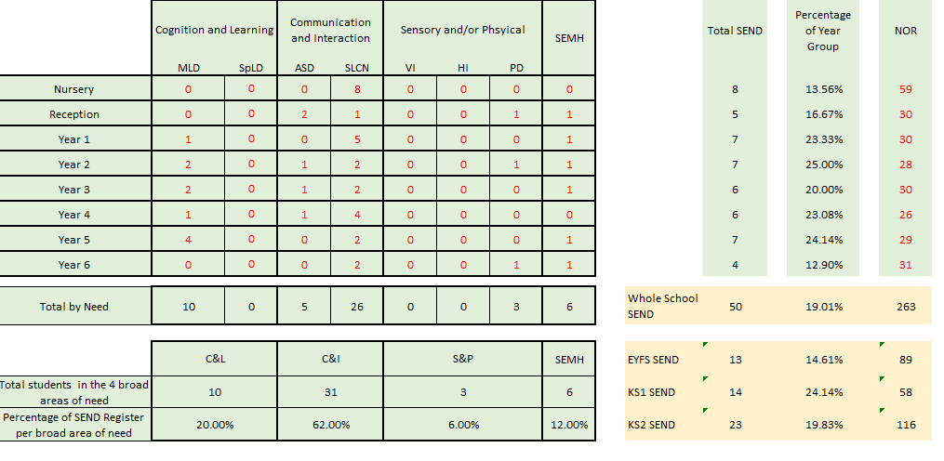

Appendix 2 – Interventions 2023-2024

The following interventions were available at the Academy during 2022-2023

Wave 1  Universal Provision | Wave 2  Short Term Provision | Wave 3  Long Term Provision
- Differentiated Curriculum  - SODA  - Learning Surgery  - Visual prompts  - Visual Timetables  - Illustrated Dictionaries  - Writing Frames & Scaffolds  - Practical resources  - Differentiated homework  - Flipped Learning  - TA Group Support  - Regular Reading  - Lexia  - Times Tables Rockstars  - Wellcomm | - Phonic intervention  - Precision Teaching  - Small group work  - Group interventions  - Boosters  - Everyday readers  - Visual phonics  - Colourful Semantics  - Lexia – additional time  - Individual Planning  - Nurture  - Reading Fluency  - 1:1 Mentoring  - Reading Buddies  - Wellcomm Intervention  - Lego therapy  - Base 25 mentoring  - Didi Dojos  - SALT Service Targets | - Additional 1:1 support during lessons  - SEND specialist teacher support  - Individualised timetable/curriculum  - Intensive Interaction  - Personalised work/activity centres  - Behaviour Plans  - OT/PT Movement Programmes  - Communication in Print  - Objects of Reference

Appendix 3 – SEND Training Record 2023-2024

Role of Person(s) Completing Training | Training Provider | Detail
SB | National College | SEN courses
SB | SEND CAT LTD | SEN in the Early Years
MP, PW | Speech and language | Intensive interaction
EW, SB | Inclusion Support | Sandwell Writing Intervention
AS, RM | Inclusion Support | De-escalation
AM | Inclusion Support | Early Communication Training
AM, RM | Inclusion Support | Structured teaching approach

